|  |  |
| --- | --- |
| **Description: Vertical full colour positive** | **Year 11 General Biology**  **Task 5 – Cells Processes** |

|  |  |  |  |
| --- | --- | --- | --- |
| **Name:** | **Teacher:** | **Date:** | **Score: /39** |

**Assessment type:** Test

**Conditions**

Time for the task: 50 minutes

**Task weighting** – 10%

Total 39 marks

__________________________________________________________________________

|  |  |  |  |  |
| --- | --- | --- | --- | --- |
|  | Section | Number of questions | Marks available | Marks achieved |
| A | Multiple choice | 11 | 11 |  |
| B | Short answer | 5 | 20 |  |
| C | Extended answer | 2 | 8 |  |
|  | Total | 17 | 39 |  |

**Part A: Multiple-choice (11 marks)**

Section A consists of 11 questions, each worth one mark. Each question has only one correct answer.

1. The cell membrane of living cells
2. Protects, supports and gives shape to the cell
3. Controls the flow of substances in and out of the cell
4. Is the part of the cell where photosynthesis
5. Supplies energy to all the other parts of the cell
6. Which organelle is the site of cellular respiration?
7. chloroplast
8. golgi apparatus
9. endoplasmic reticulum
10. mitochondrion
11. Where does gas exchange occur in animals?
12. Left Broncus
13. Trachea
14. Alveoli
15. Terminal Bronchiole
16. Photosynthesis in green plants only occurs when the plant is in the light. When does respiration occur in green plants?
17. Only in the dark
18. At all times
19. Only in the light
20. When sufficient ATP is present
21. Which of the following is not directly needed by plants for photosynthesis?
22. carbon dioxide
23. bacteria
24. light
25. water
26. The green pigment in a plant is called ___________.
27. Chlorophyll
28. Chlorine
29. Mitochondria
30. Mesophyll
31. What is the term that is best described as the diffusion of water through a selectively permeable membrane?
32. Diffusion
33. Osmosis
34. Water transfer
35. All of the above
36. All of the following are parts of the equation for cellular respiration, EXCEPT
37. glucose
38. oxygen
39. carbon dioxide
40. ADP

Use the following diagram to answer questions 16 and 17.

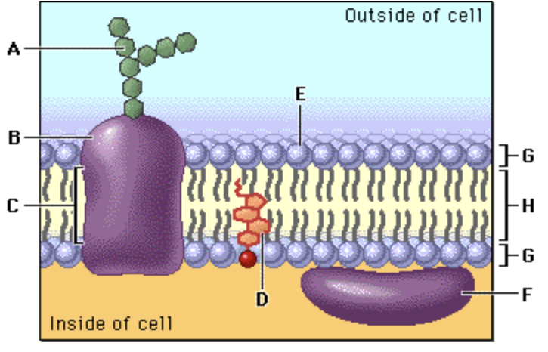

1. In the diagram, structure E corresponds to:
2. Protein
3. Carbohydrate
4. Lipid layer
5. A hydrophilic structure
6. In the diagram above, structure H corresponds to:
7. A hydrophobic structure
8. Cholesterol
9. An integral protein
10. A hydrophilic structure
11. What is osmosis?
12. Diffusion of water through a semi-permeable membrane
13. When you take water out of a cell
14. When you put water into the cell
15. When you put water out the cell

**END OF MULTIPLE CHOICE QUESTIONS**

**Part B: Short answer (20 marks)**

Answer all questions in the spaces provided.

1. Define the following

Active transport

Passive transport

1. Describe **how** surface area to volume ratio can affect the rate of diffusion of different types of substances across membranes. (2 marks)

1. Describe what has happened in the diagram below. (2 marks)

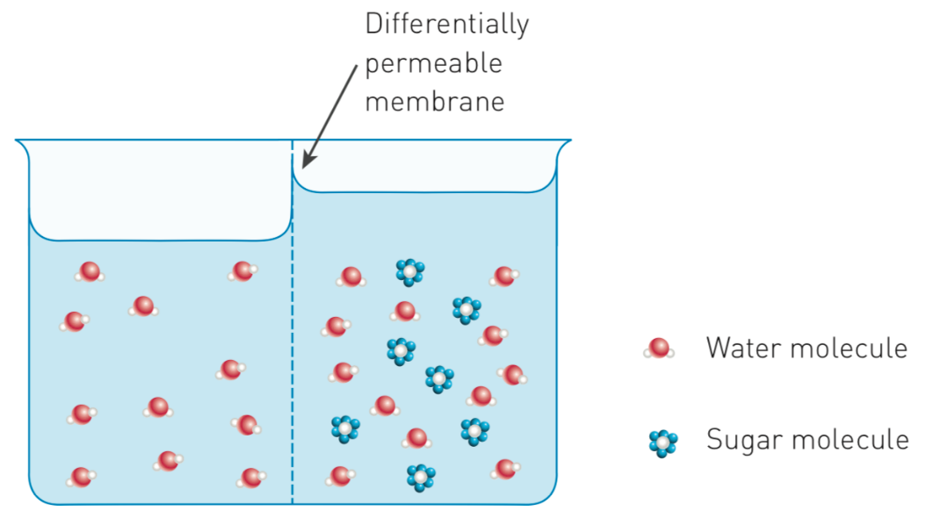

1. The transportation of sugars and water within plants is essential for life. On the diagram of a tree below, use a blue pen to draw arrows to show the direction of water movement. Use a red pen to draw arrows to show the direction of sugar movement.

(1 mark)



1. Photosynthesis is a series of chemical reactions catalyzed by enzymes that occurs in the chloroplasts of plant cells.

Identify the appropriate terms to label the figure below.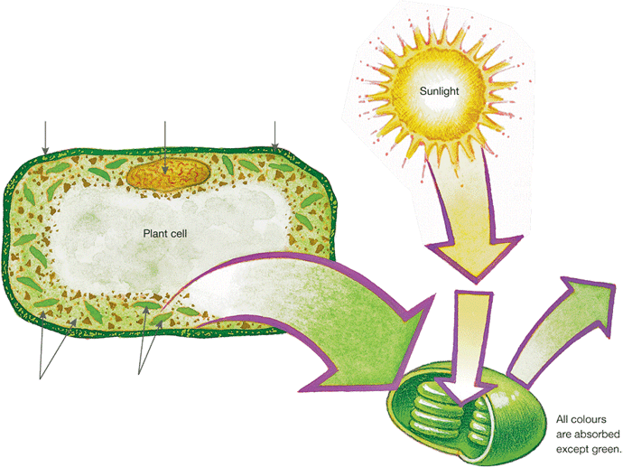 (3 marks)

1. Write a word equation for photosynthesis. (2 marks)

_________________________________________________________________________________

1. Write a word equation for respiration. (2 marks)

_________________________________________________________________________________

1. Write a chemical equation for respiration. (2 marks)

_________________________________________________________________________________

1. A man was training for a 15 km fun run. He noticed that after 10 km his legs started to ache. Explain what is happening inside his muscle cells. (2 marks)

1. What is the main difference between AEROBIC and ANAEROBIC respiration?

(2 marks)

END OF SHORT ANSWER QUESTIONS

**Section C: Short Answer (8 marks)**

**Section C consists of 2 questions**.

Write your answers in the spaces provided. You are advised to spend 10 minutes on this section.

1. A student set up the following experiment.



The experiment was left out on an open oval from 7:00 am to 5:00 pm on a sunny day. Explain the difference in the concentration of oxygen and carbon dioxide in the jars. (4 marks)

Oxygen concentration

Carbon dioxide concentration

2. The cells below are erythrocytes (red blood corpuscles). Varying amounts of sucrose were added to the extracellular environments A, B and C. Each of the three pictures depicts them in a different extracellular environment.

Describe fully the **solutions** and the **processes** that occur in the stages shown at **A** and **C**.

(4 marks )

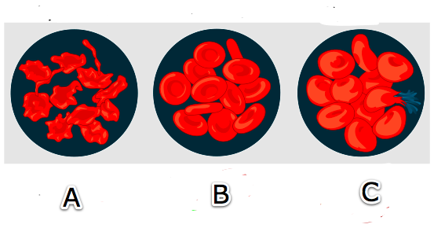

Stage A

Stage C

END OF TEST